Dr Paul Moore Dr Lucy Stewart Dr Kate Tranter Dr Geraldine Vaughan Dr Steven Roberts Dr Rohit Gupta

Mrs Karen Ford

***QUAYSIDE MEDICAL PRACTICE***

Chapel Street Newhaven East Sussex BN9 9PW

Tel 01273 615000

Fax 01273 611527

[www.quaysidemedicalpractice.nhs.uk](http://www.quaysidemedicalpractice.nhs.uk)

**Website Adult Registration Form**

Please ensure this form is returned fully completed along with the purple GMS1 form which is also available on the website

Allpatients are required to produce two forms identity when registering with a Doctor. One form of Photo ID is required along with one form of ID with proof of address.

Please complete this form to register as a permanent patient with the practice and provide the receptionist with two of the following forms of ID:-

* Birth/Marriage Certificate
* Driving Licence
* Passport
* Local Authority rent card
* Paid utility bills
* Bank statements
* National Insurance Number card
* Wage slip

As a new patient you will also be offered a Health Check at the time of registering, this appointment will be with one of our Health Care Assistants.

For information regarding what the practice has to offer for patients please see the practice leaflet or visit the website as above.

New medical cards will no longer be issued routinely to all new patients. If you would like a medical card or need to obtain your NHS number you can contact the Kent Primary Care Agency by phoning the patient enquires office on 01622 655147.

We would like to take the opportunity to welcome you to Quayside Medical Practice.

______________________________________________________________

**For admin purposes only:**

|  |  |  |  |  |  |
| --- | --- | --- | --- | --- | --- |
| ID Viewed: | | | | | |
| Birth Certificate |  | Passport |  | Bank Statement |  |
| Marriage Certificate |  | LA Rent Card |  | NI Card |  |
| Driving Licence |  | Utility Bill |  | Pay Slip |  |

**Recording of Ethnic Group**

**Information for Patients**

This practice, in line with other healthcare providers, collects information about the ethnic group of patients. This information can help us plan to meet the needs of the community and ensure that everyone has equal access to the healthcare we provide.

**Please note, we are not asking you about citizenship or nationality, but about the ethnic group to which you feel you belong.**

All the information we receive will be used and treated with the strictest confidence. Any information used for service planning purposes will be anonymous with all names and other identifying information removed.

The classification is entirely voluntary but will help provide a better service. If you do not wish to provide this information, please tick the “not stated” box below.

If you have any queries about completing this form, please ask a staff member. Otherwise please complete the form below by ticking the appropriate box.

|  |  |
| --- | --- |
| **Ethnic Group** | **Please tick** |
| White: British |  |
| White: Irish |  |
| White: Any other white background |  |
| Mixed: White and Black Caribbean |  |
| Mixed: White and Black African |  |
| Mixed: White and Asian |  |
| Mixed: Any other mixed background |  |
| Asian or Asian British: Indian |  |
| Asian or Asian British: Pakistani |  |
| Asian or Asian British: Bangladeshi |  |
| Asian or Asian British: Any other Asian background |  |
| Black or Black British: Caribbean |  |
| Black or Black British: African |  |
| Black or Black British: Any other Black background |  |
| Other ethnic groups: Chinese |  |
| Other ethnic groups: Any other ethnic group |  |
| Not stated |  |

**Electronic Communication Form**

The practice offers patients to opportunity for receive information electronic communication. Please read the information below and sign in the box should you wish to receive information electronically.

I hereby consent to the practice contacting me by text message for the purposes of appointment reminders and test results on the contact number given below.

I understand that the forwarding of appointment reminders / test results by text is an additional service provided by the practice and these may not be sent on all occasions.

I understand that I remain responsible for attending or cancelling appointments and contacting the surgery for any test results.

I understand that although text messages are generated using a secure facility they are transmitted over a public network onto a personal telephone and as such may not be secure.

I understand that I am responsible for notifying the practice of any change in contact details.

I understand that I have the right to cancel the text message facility at any time.

|  |  |
| --- | --- |
| Patient’s Signature:  Date: |  |
| Where the patient is under the age of 16, consent may be given by a person holding Parental Responsibility. All patients attaining the age of 16 years will be required to provide their signed consent for this service to be continued. | |
| Name of person holding Parental Responsibility: |  |
| Signature:  Date: |  |

**Online Access Application**

The practice offers patients the opportunity to book appointments and request prescriptions online please read the information below and sign in the box should you wish to apply for this service. **Please ensure you have provided Photo ID before completing this form.**

I would like to apply for access to book appointments and/or order repeat prescriptions online.

I understand that I will be provided with a user code that will be unique to my patient record

I understand that I will not be able to use this code to book appointments/order repeat prescriptions for any other patient.

I understand that I am responsible for notifying the practice of any change in contact details.

I understand that I remain responsible for attending or cancelling appointments.

I understand that the practice reserves the right to withdraw this access if this service is used inappropriately.

I understand that this gives the practice consent to email me notifications for clinical services if required.

I would like to receive my online access registration information via:

Email

|  |  |
| --- | --- |
| Patient’s Signature:  Date: |  |
| Where the patient is under the age of 16, online access may be applied for by a person holding Parental Responsibility. All patients attaining the age of 16 years will be required to apply for access for this service to be continued. | |
| Name of person holding Parental Responsibility: |  |
| Signature:  Date: |  |

Reception (collection in five complete working days)

**More Information**

**Personal details**

Mobile Number: _____________________________________

Email Address: _____________________________________

Are you a Carer Yes / No

A Carer is anyone who cares, unpaid, for a friend or family member who due to illness, disability, a mental health problem or an addiction cannot cope without their support.

Other people at same address?:

(Names of children/partner)

Have you previously been registered at our practice: YES  NO

**Pharmacy Nomination**

Please nominate below a pharmacy you wish to collect your prescriptions from. Your prescriptions will be produced by the GP and electronically transmitted to your nominated pharmacy without the need to produce a paper prescription unless you would like one. Please note that if you have nominated a pharmacy at your previous practice this nomination will be cleared unless you state otherwise.

Please tick the box below, state your pharmacy and sign your consent for us to nominate your chosen pharmacy.

* I confirm that the Electronic Prescribing Service has been explained to me and I have also been offered a leaflet that explains nomination.

|  |
| --- |
| Name and address of nominating Pharmacy/dispenser: |
|  |

|  |  |
| --- | --- |
| Signed: |  |
| Printed (please state relationship to patient if appropriate): |  |
| Date: |  |

**Health Information**

**Current Medical Problems** :(e.g. Asthma, High Blood Pressure)

|  |  |
| --- | --- |
| **Current medication**  (please attach printed list/repeat request if available) | |
| Drug Name | Dose |
|  |  |
|  |  |
|  |  |
|  |  |
|  |  |
|  |  |
|  |  |
|  |  |
|  |  |

**Allergies**

(drugs/food/dressings etc)

|  |  |  |
| --- | --- | --- |
| **Family History** (are there any illnesses that run in the family?) | | |
|  | Yes | No |
| Heart Disease (when under 60 years old) |  |  |
| Diabetes |  |  |
| Cancer |  |  |
| Please give details: | | |

**Habits**

Are you a smoker?: YES  NO

**If yes**, how much do you smoke: ___________________________

**If no**, have you ever been a smoker? YES  NO

(Please record how long for/when stopped)

_____________________________________________________

Do you drink alcohol? YES  NO

If yes, please answer the questions in the table below;

|  |  |  |  |  |  |  |
| --- | --- | --- | --- | --- | --- | --- |
| Questions | Scoring system | | | | | Your score |
| 0 | 1 | 2 | 3 | 4 |
| How often do you have a drink that contains alcohol? | Never | Monthly or less | 2-4 times per month | 2-3 times per week | 4+ times a week |  |
| How many standard alcoholic drinks do you have on a typical day when you are drinking? | 1-2 | 3-4 | 5-6 | 7-8 | 10+ |  |
| How often do you have 6 or more standard drinks on one occasion? | Never | Less than Monthly | Monthly | Weekly | Daily or almost daily |  |

**Scoring: A total of 5+ indicates hazardous or harmful drinking**

**For Office Use:**

New Patient Health Check offered: Yes  No

New Patient Health Check booked: _________________________

New Patient Health Check declined:

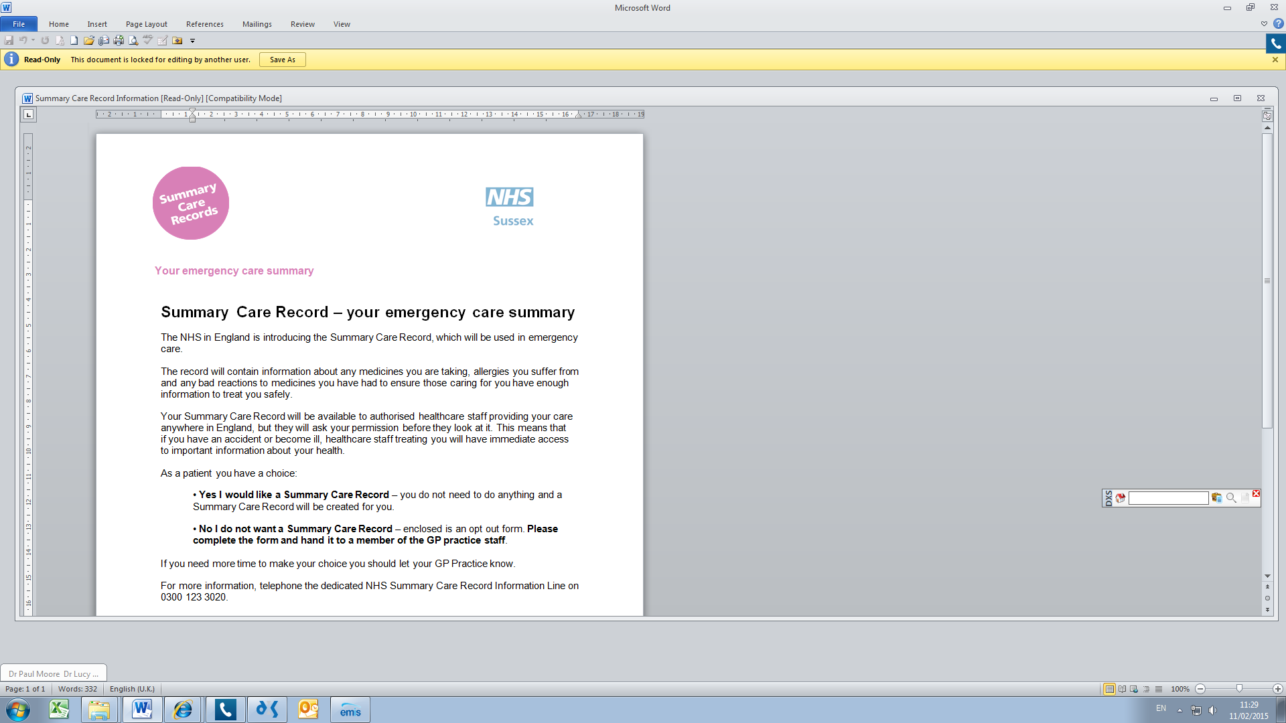**Summary Care Record – your emergency care summary**

The NHS in England is introducing the Summary Care Record, which will be used in emergency care.

The record will contain information about any medicines you are taking, allergies you suffer from and any bad reactions to medicines you have had to ensure those caring for you have enough information to treat you safely.

Your Summary Care Record will be available to authorised healthcare staff providing your care anywhere in England, but they will ask your permission before they look at it. This means that

if you have an accident or become ill, healthcare staff treating you will have immediate access to important information about your health.

As a patient you have a choice:

• **Yes I would like a Summary Care Record** – you do not need to do anything and a Summary Care Record will be created for you.

• **No I do not want a Summary Care Record** – enclosed is an opt out form. **Please complete the form and hand it to a member of the GP practice staff**.

If you need more time to make your choice you should let your GP Practice know.

For more information, telephone the dedicated NHS Summary Care Record Information Line on 0300 123 3020.

Additional copies of the opt out form can be collected from the GP practice, printed from the website **www.nhscarerecords.nhs.uk** or requested from the dedicated NHS Summary Care Record Information Line on 0300 123 3020.

**You can choose not to have a Summary Care Record and you can change your mind at any time by informing your GP practice.**

If you do nothing we will create a Summary Care Record for you. Children under 16 will automatically have a Summary Care Record created for them unless their parent or guardian chooses to opt them out. If you are the parent or guardian of a child under 16 and feel that they are old enough to understand, then you should make this information available to them.

